Upload link radio button addion
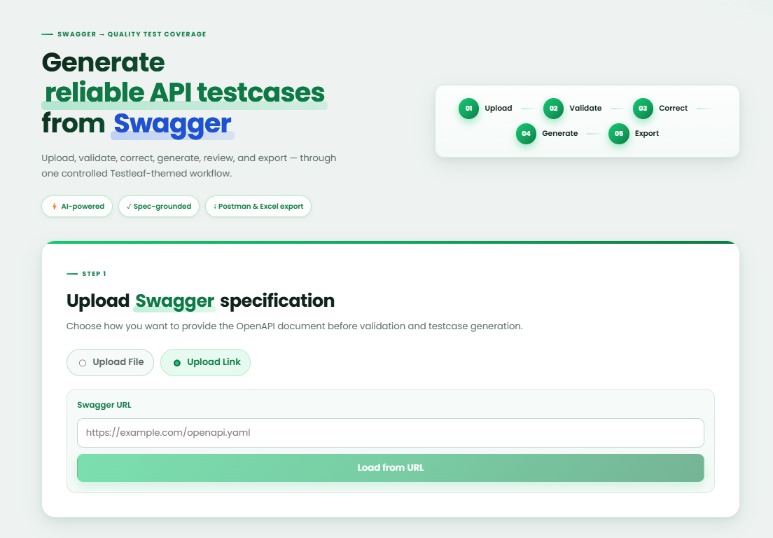

Swagger URl validation and toaster message
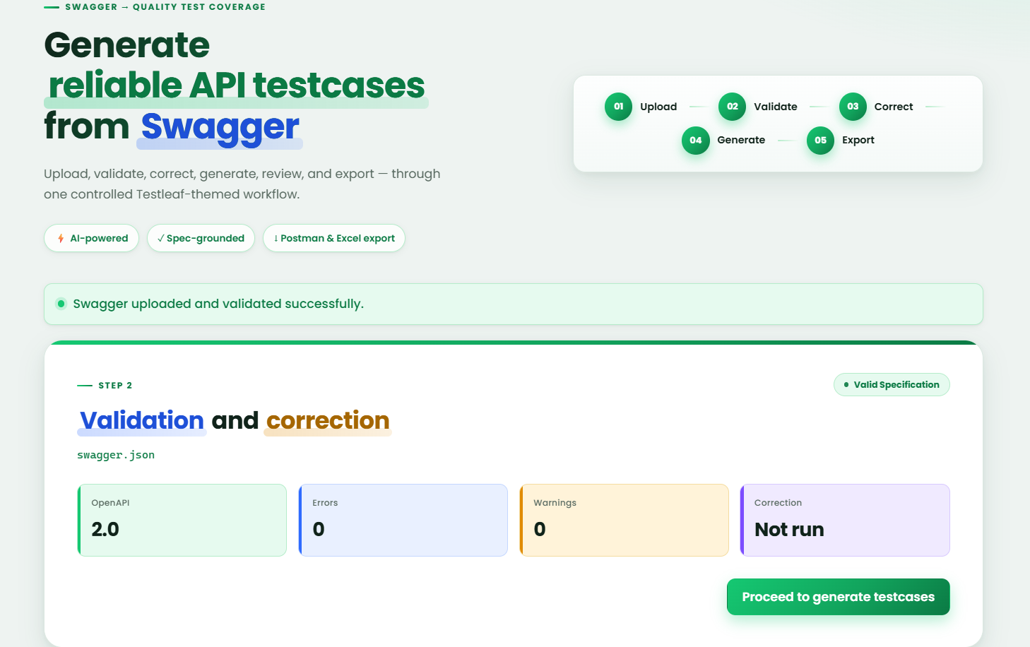

Test case generation from Swagger URL
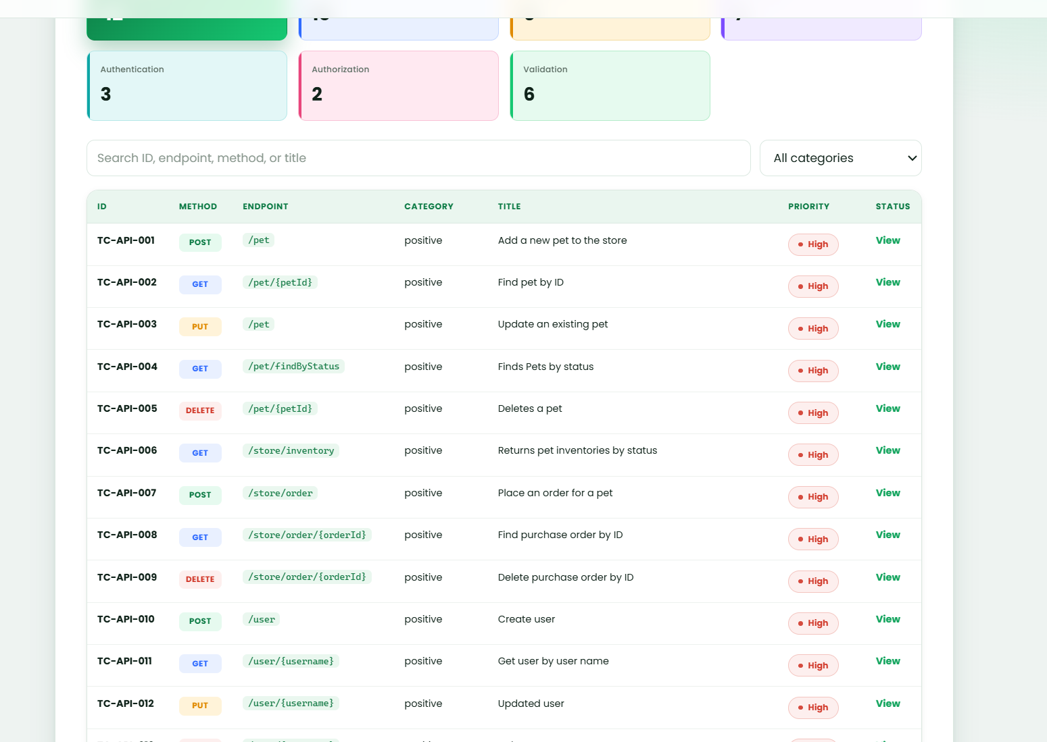

Test categorization filter added in the existing implementation for smoke, Sanity, Regression and Functional 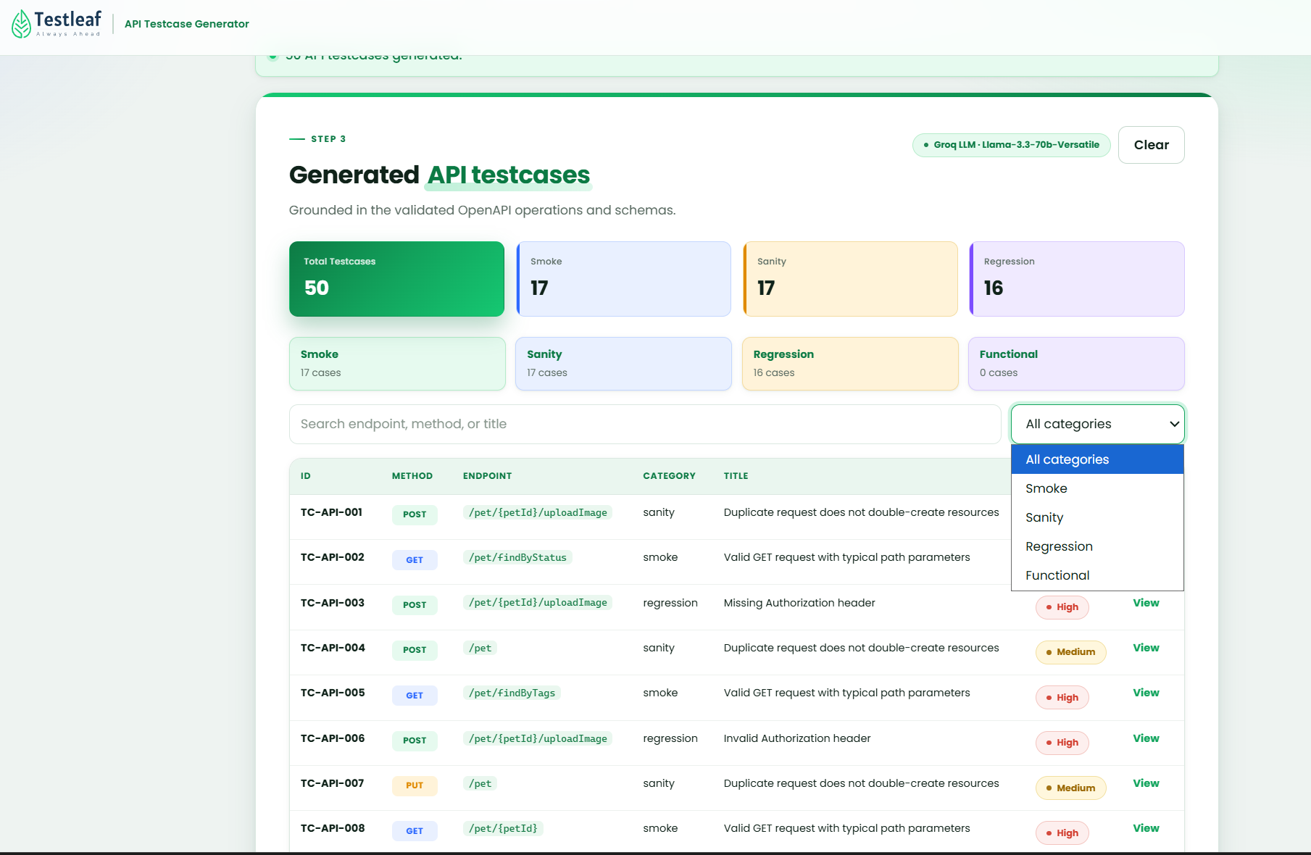
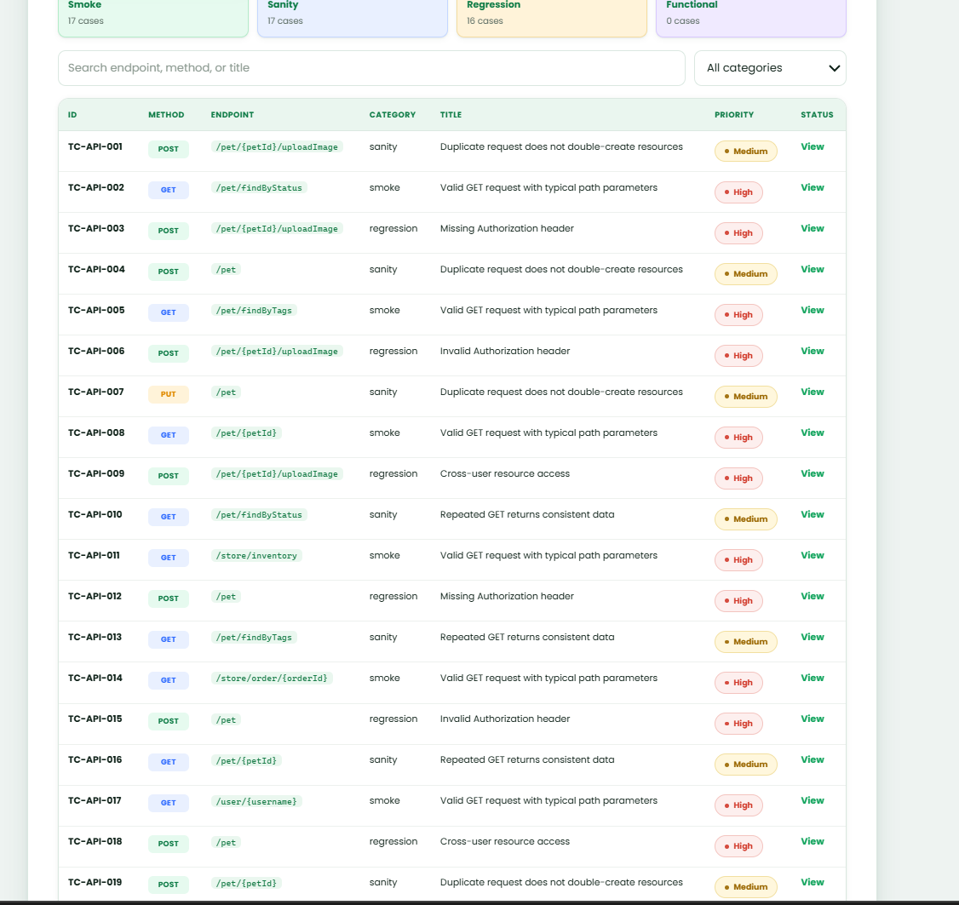

Implementation Details
- Existing application is enhanced with radio button to accept link from swagger URL.
- Swagger URL is validated and toaster message provided.
- Test case generation from swagger URL.
- Existing application is enhanced to categorize generated test cases into Smoke, Sanity, Regression and Functional and filter to add to view the test cases.
- Existing test case generation flow with file upload is maintained and not affected by this new implementation.

